**HomeWork #1 - Ansible**

**Git Repo : https://github.com/TPriyanka22/CMPE-272-HW1**

**1. Create three EC2 instances in AWS :**

**To configure Configure Ansible server on *VirtualMachine 1* to deploy a webserver *to VirtualMachine2* and *VirtualMachine3* on port 8080 that displays the message: “Hello World from SJSU-X”, where X is 1 or 2 depending on which web server.**

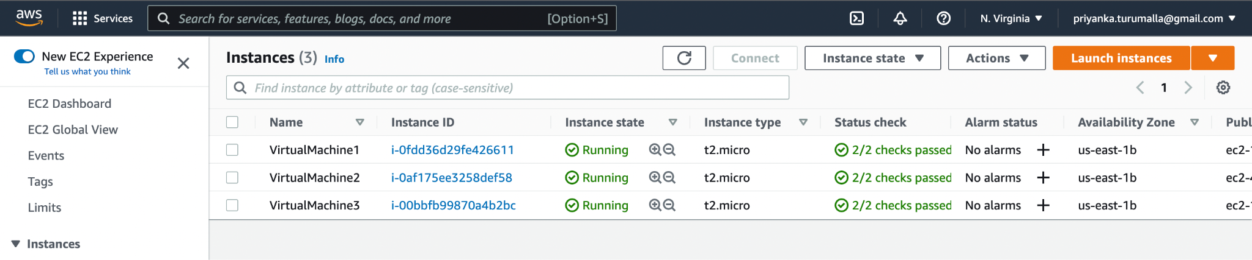

**PublicIps and PrivateIps of VM2 and VM3 are given below:**





**2. Edit the inbound rules to set TCP port 8080.**

**3. Connect each individual instances and launch them.**

**4. With the help of the commands *sudo apt-get update* and *sudo apt-get upgrade* download the required package information.**

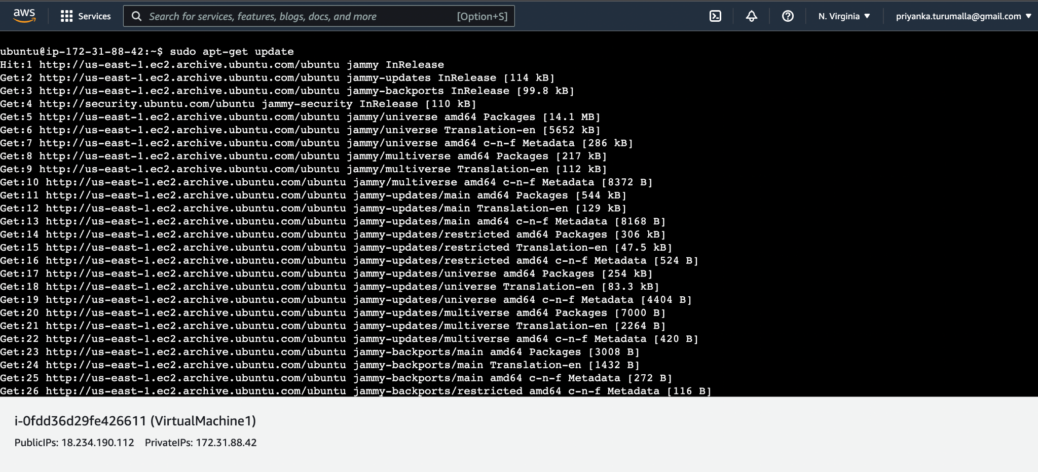

**5. The next step is to install Ansible in VirtualMachine 1 with the help of command *sudo apt-get install ansible*.**

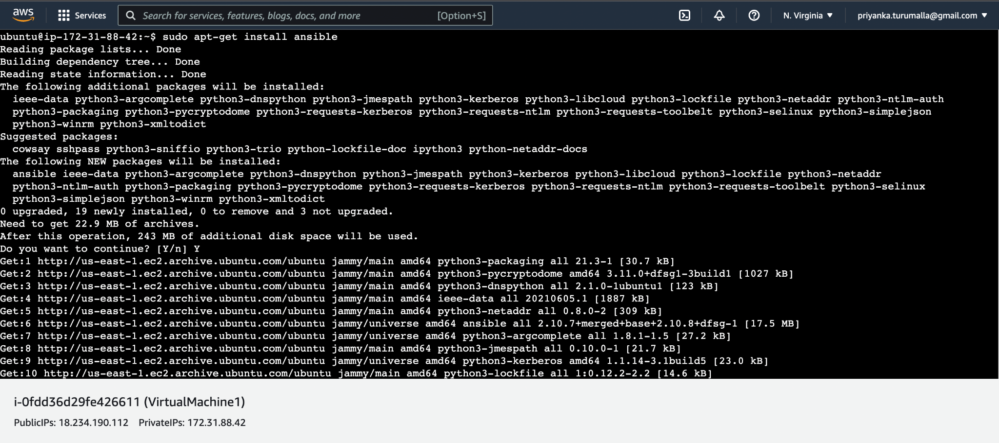

**6. To provide secure encrypted communications between hosts we need to install openSSH server and**

* **Create the RSA key pair**
* **Store the keys and passphrase**

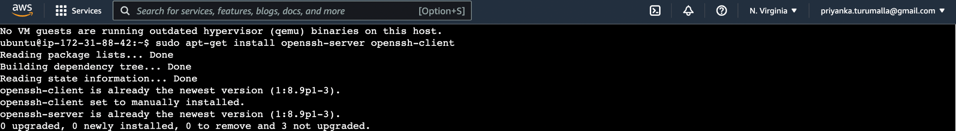

**Since the SSH private key normally includes a password, attackers require both the SSH private key and knowledge of this password. Thus we need to configure SSH as below:**

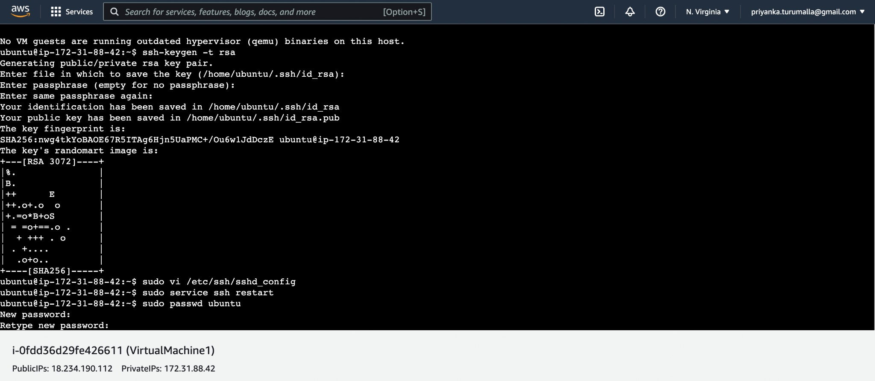

**8. To change the contents of the default Ansible inventory, use the mkdir command to create the /etc/ansible directory as below:**

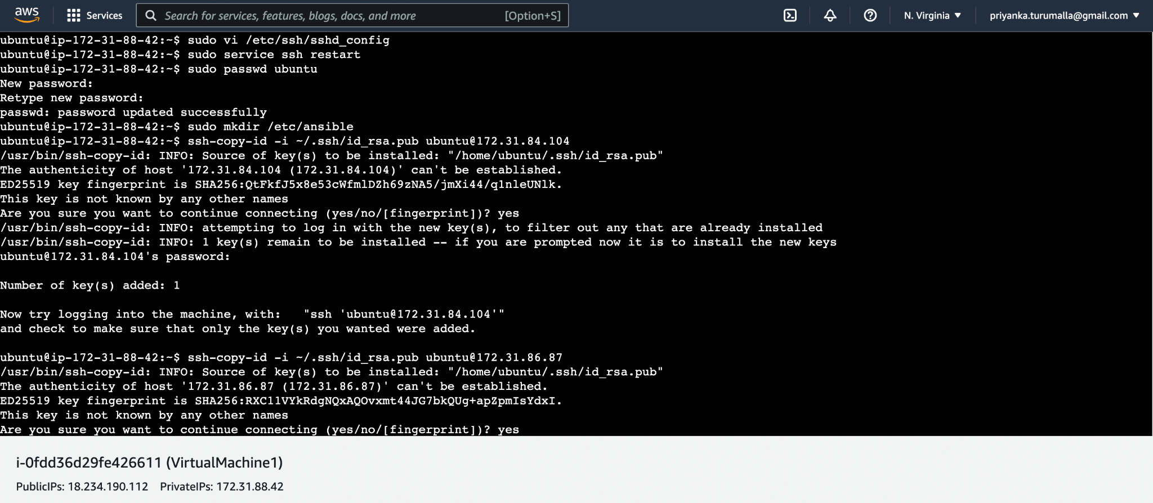

**9. Update the hosts file with the host name and required Private IP address of VM2 and VM3 and for dynamically changing the message based on web server, ‘server’ is used.**

**Git link - https://github.com/TPriyanka22/CMPE-272-HW1/blob/main/hosts**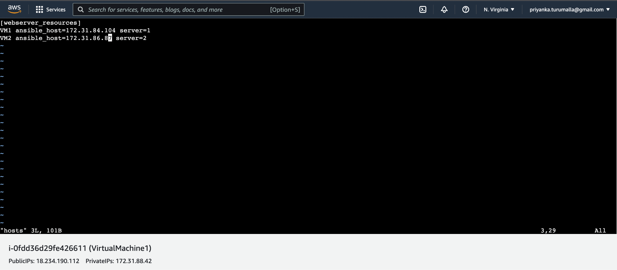

**10. All tasks from this setup are defined in the deployresources.yml file. It begins by defining the group of servers that will be the target of this setup. Tasks would include to install apache and configure to it to listen on port 8080**

**Git link - https://github.com/TPriyanka22/CMPE-272-HW1/blob/main/deployresources.yml**

**11. Index.html is the html file to display the message**

**Git link - https://github.com/TPriyanka22/CMPE-272-HW1/blob/main/index.html**

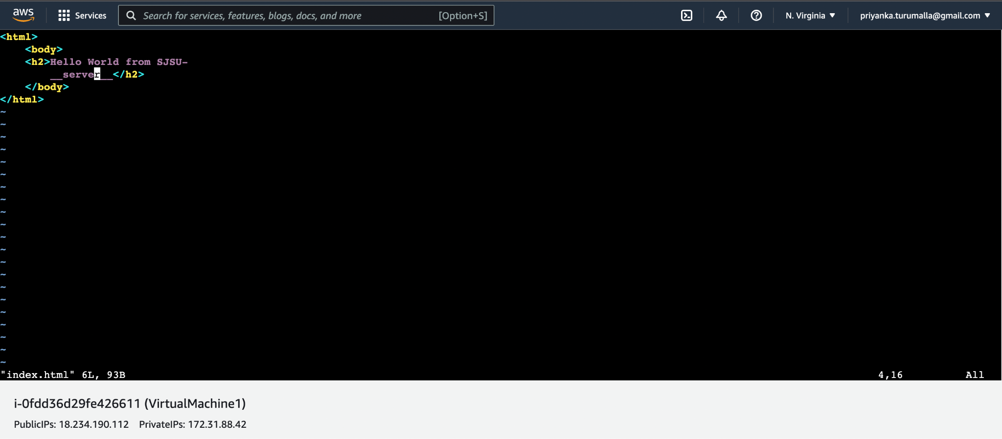

**12. Execute the playbook or the yml file deployresources by using the following command :**



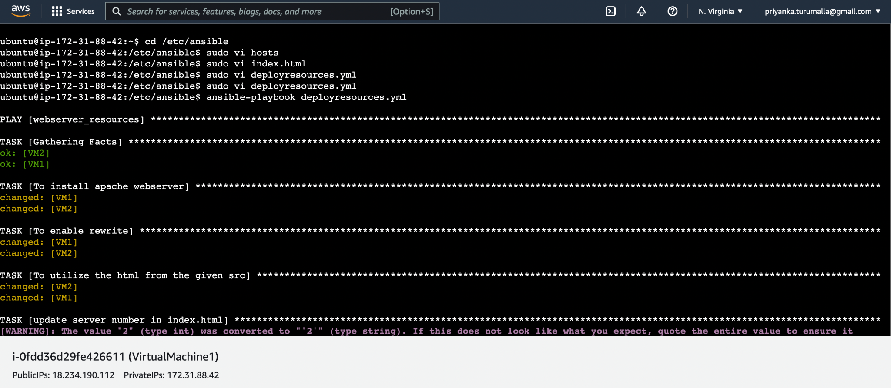

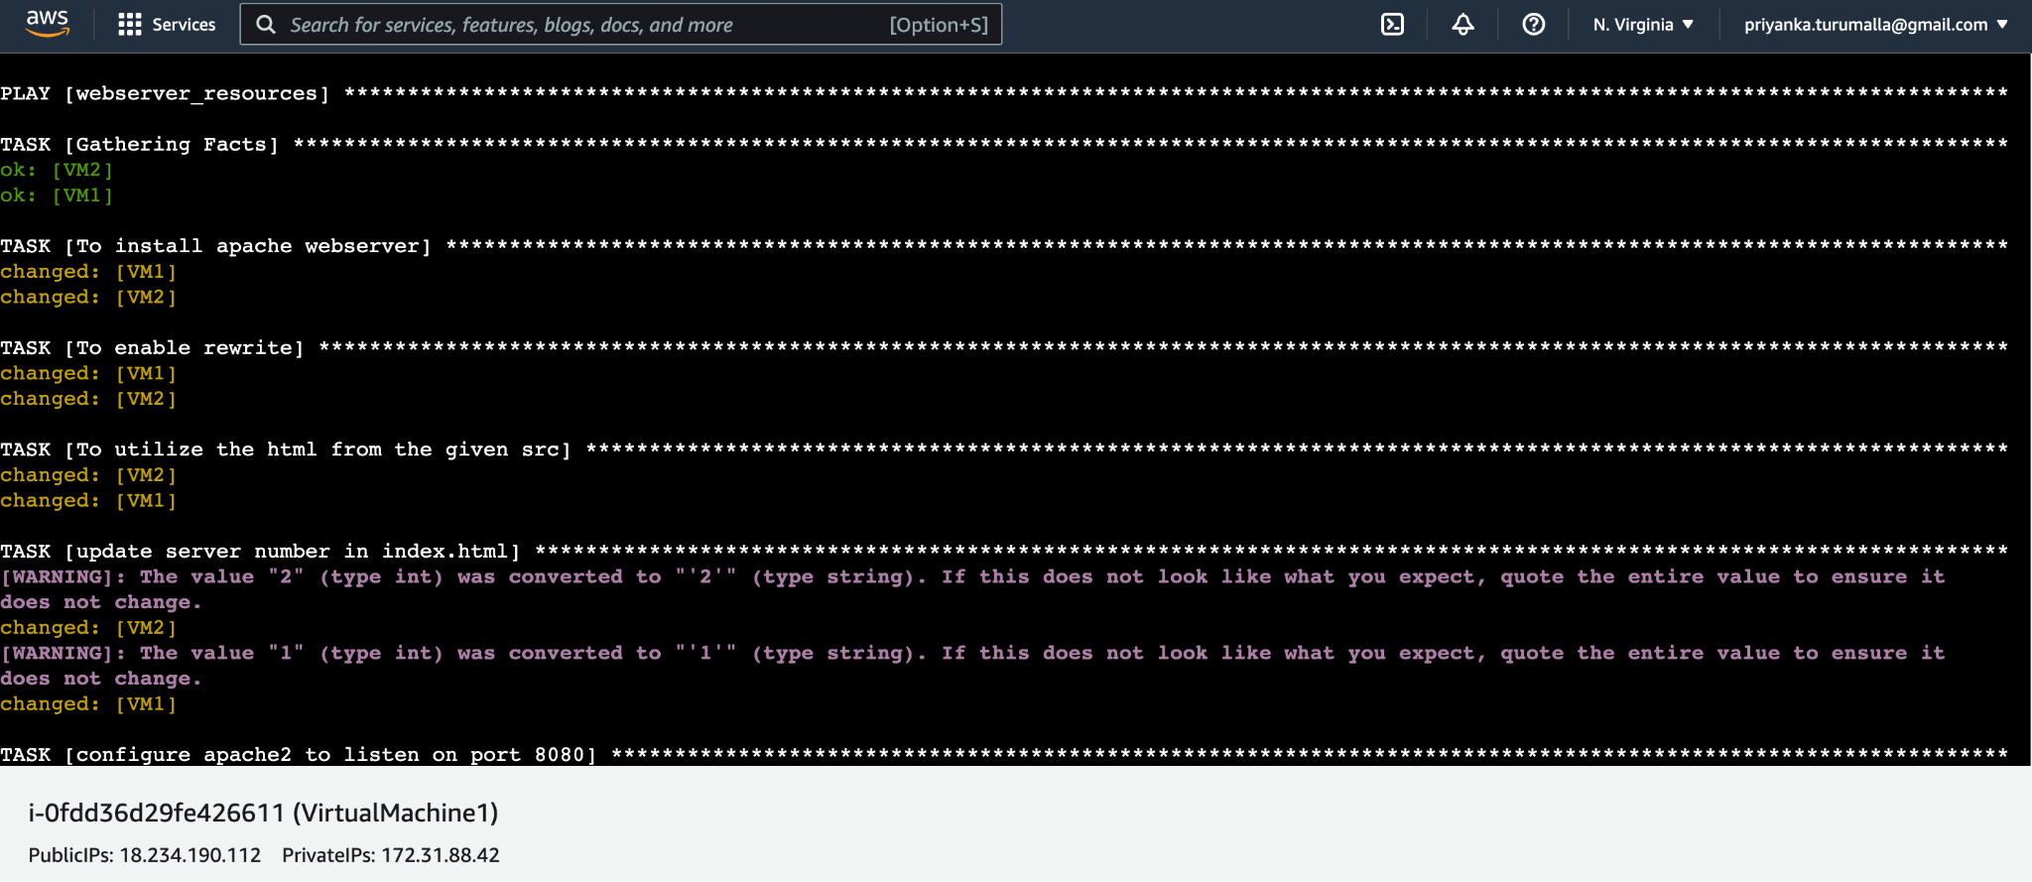

**13. With the help of public Ip address verify the webserver deployed on VM2 and VM3. In this case, both are working as expected.**

**Public Ip Addrees for VM2 - 44.206.237.126**

**Public Ip Address for VM3 - 107.21.83.179**

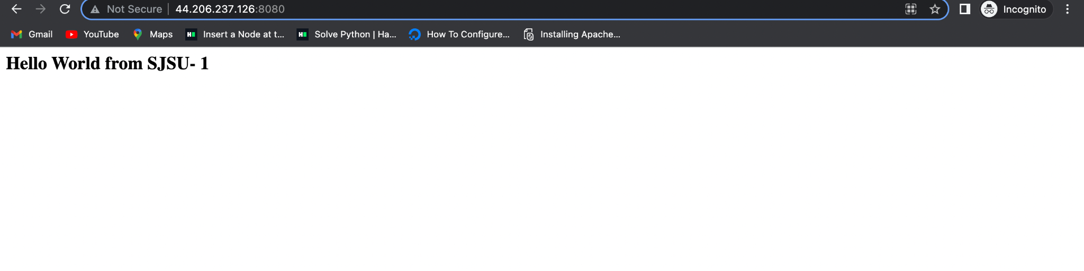

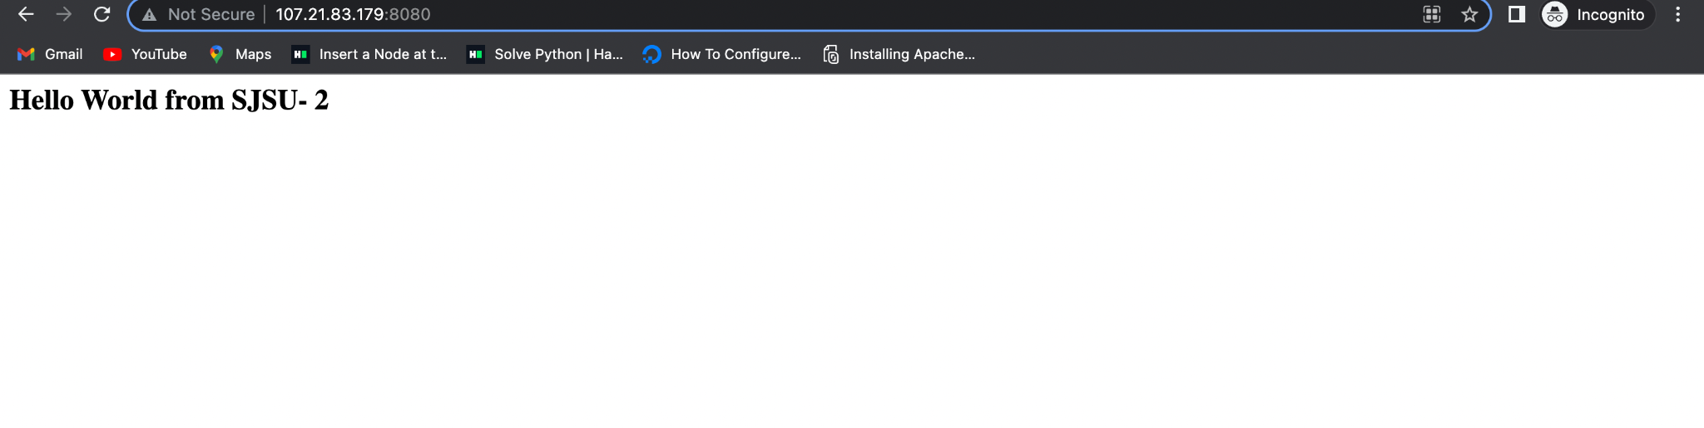

**14. Verify resources being undeployed on Virtual Machines VM2 and VM3**

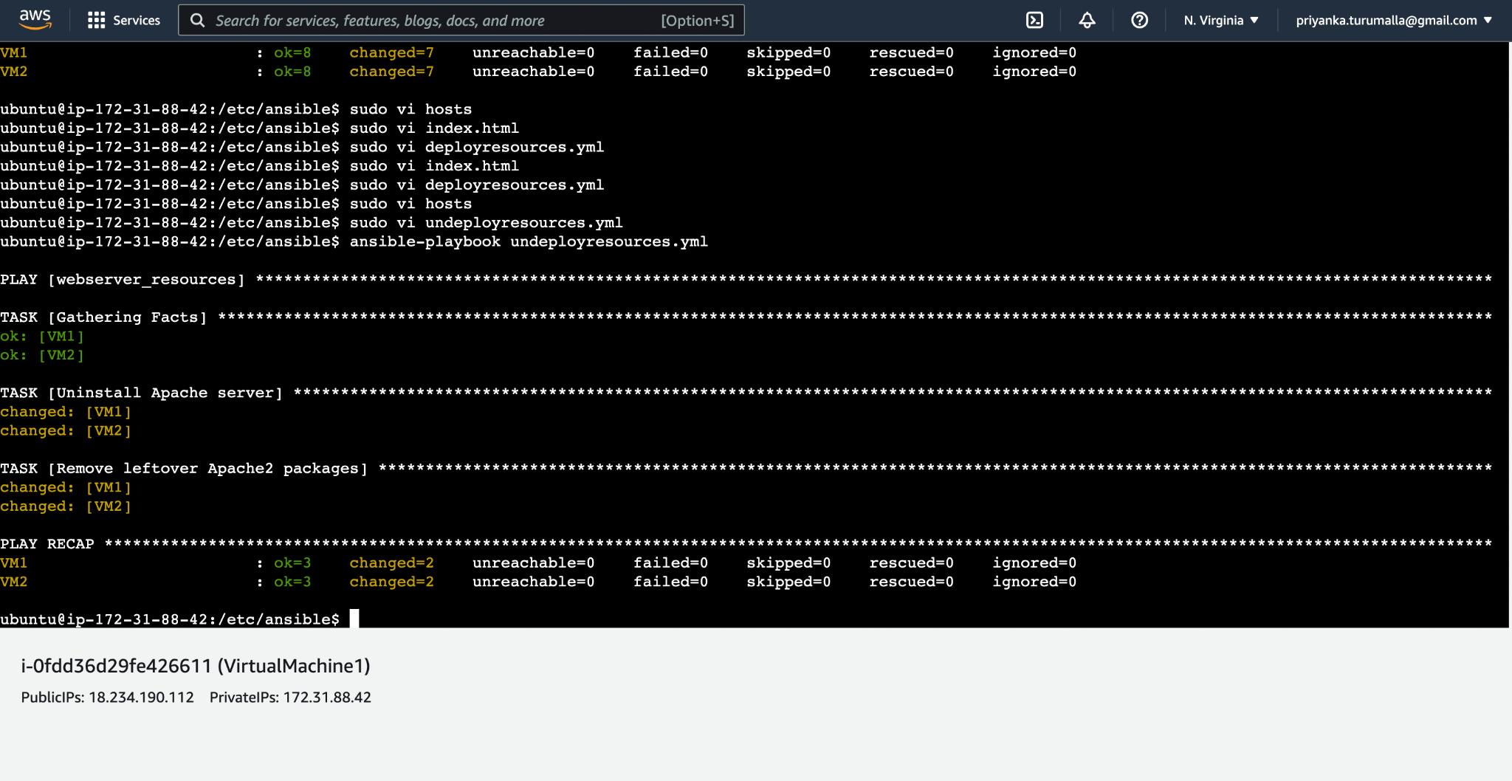



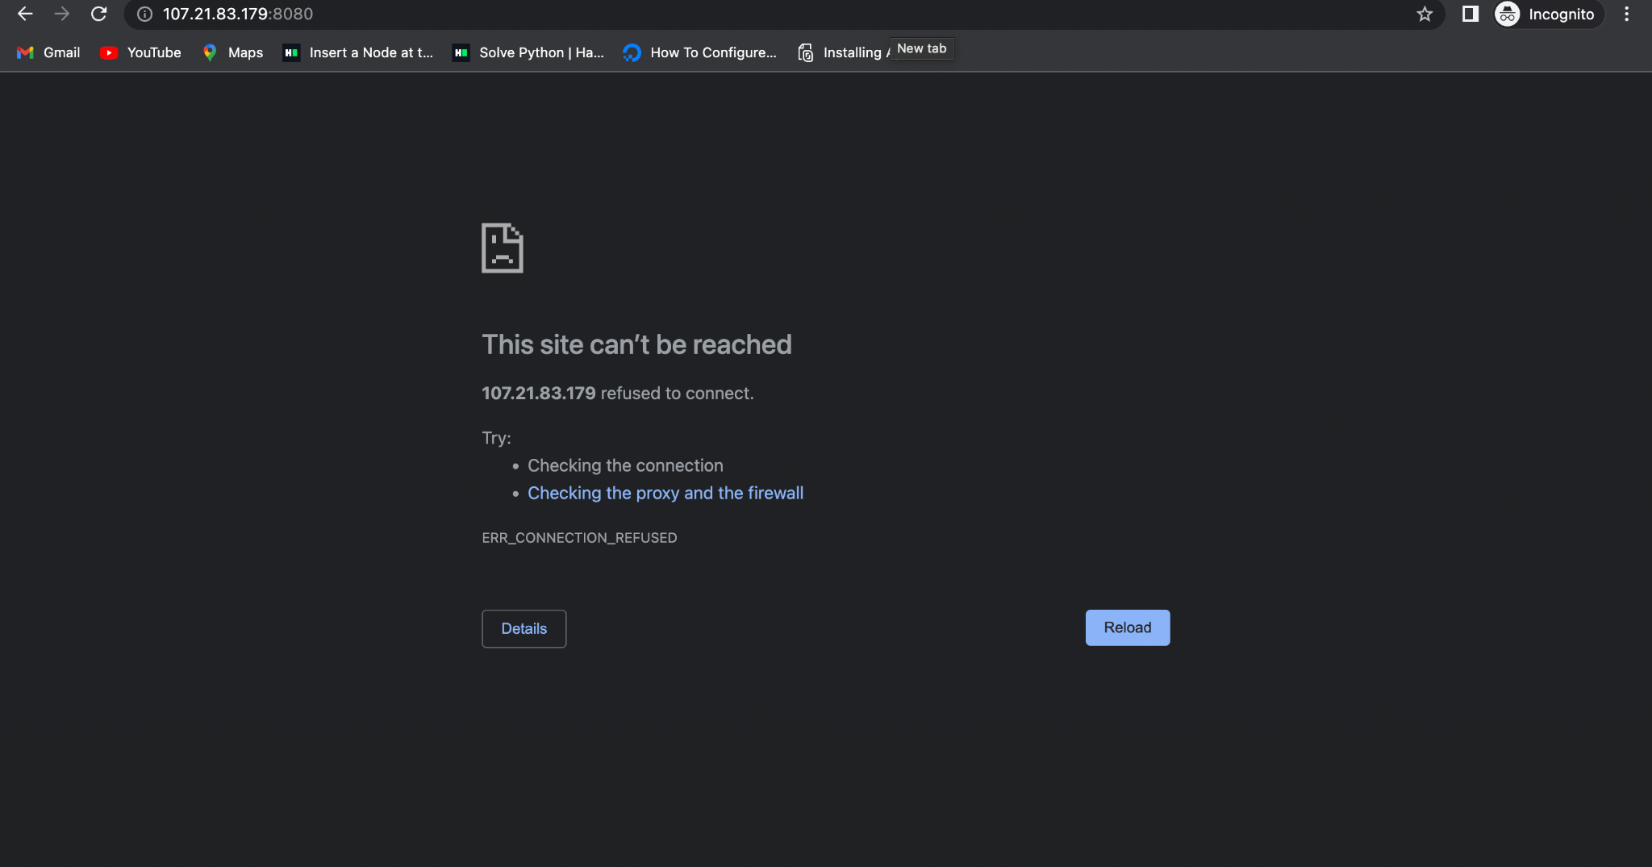

**References :**

[**https://www.linuxtechi.com/how-to-install-ansible-on-ubuntu/**](https://www.linuxtechi.com/how-to-install-ansible-on-ubuntu/)

[**https://www.digitalocean.com/community/tutorials/how-to-use-ansible-to-install-and-set-up-apache-on-ubuntu-18-04**](https://www.digitalocean.com/community/tutorials/how-to-use-ansible-to-install-and-set-up-apache-on-ubuntu-18-04)

[**https://www.deciusac.com/linux-2/how-to-set-up-ssh-keys/**](https://www.deciusac.com/linux-2/how-to-set-up-ssh-keys/)

[**https://linuxtect.com/how-to-generate-ssh-public-private-keys/#:~:text=The%20ssh%2Dkeygen%20is%20used,current%20user%20home%20directory%20~%2F**](https://linuxtect.com/how-to-generate-ssh-public-private-keys/#:~:text=The%20ssh%2Dkeygen%20is%20used,current%20user%20home%20directory%20~%2F)**.**